Ex. No. : 03
Register No. : 240701045 Name : Aparna R
Job Application Reports Suite — Report Types Use Case

1. Objective
To design and build a complete suite of Reports in Zoho Creator for the existing "Job Application
Form" application, demonstrating the correct usage of all nine Report Types available in Zoho
Creator — List View, Spreadsheet View, Kanban View, Calendar View, Map View, Timeline View,
Pivot Table, Chart View, and Summary View — so that HR and hiring managers can view,
analyze, and act on candidate data from multiple perspectives.
2. Problem Statement
The Job Application Form captures rich candidate data, but a single default list of records
cannot serve every stakeholder's needs. HR needs a quick way to update interview and
screening status in bulk, hiring managers need to see how many interviews are scheduled on a
given day, recruitment marketing needs to see where candidates are applying from
geographically, and leadership needs summarized hiring-pipeline counts and trend charts to
plan headcount and recruiting spend.
Design a complete set of Reports on top of the Job_Application_Form in Zoho Creator, using
every Report Type Zoho Creator provides, so that each stakeholder group has a purpose-built
view suited to how they need to consume the recruitment data.
3. Scope of the Use Case
• Application Name: Recruitment & Job Application Management
• Base Form: Job_Application_Form
• Primary Users: HR Recruitment Team, Hiring Managers, Interview Panels, Leadership
• Deliverable: Nine purpose-built Reports, one for each Zoho Creator Report Type
• Objective of the Reports Suite: Give every stakeholder a report format best suited to their
specific decision-making need.
1.List view
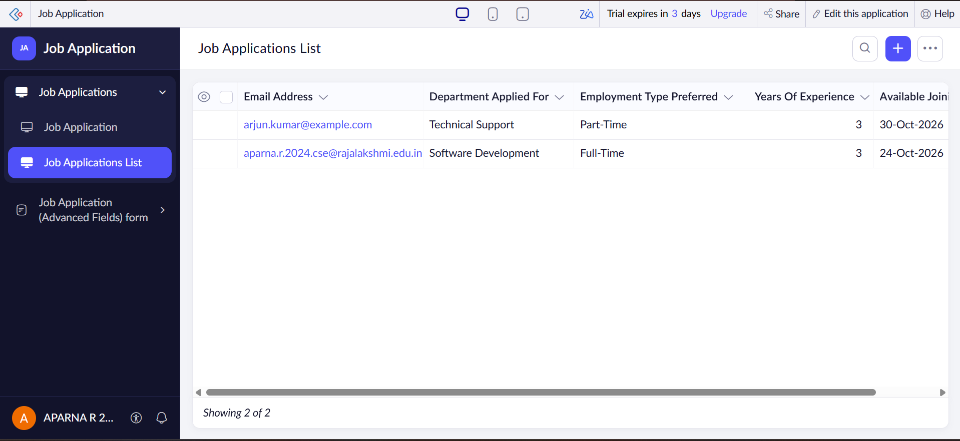
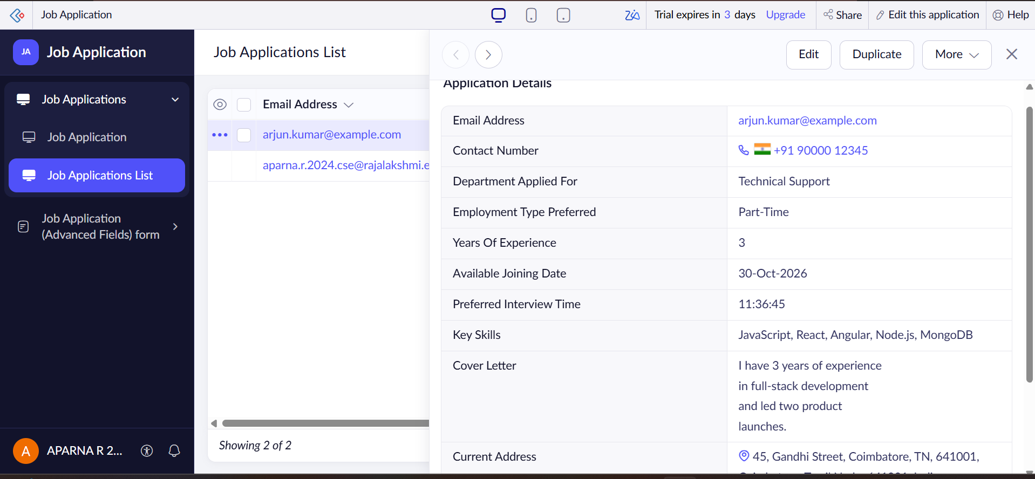

2. Spreadsheet View
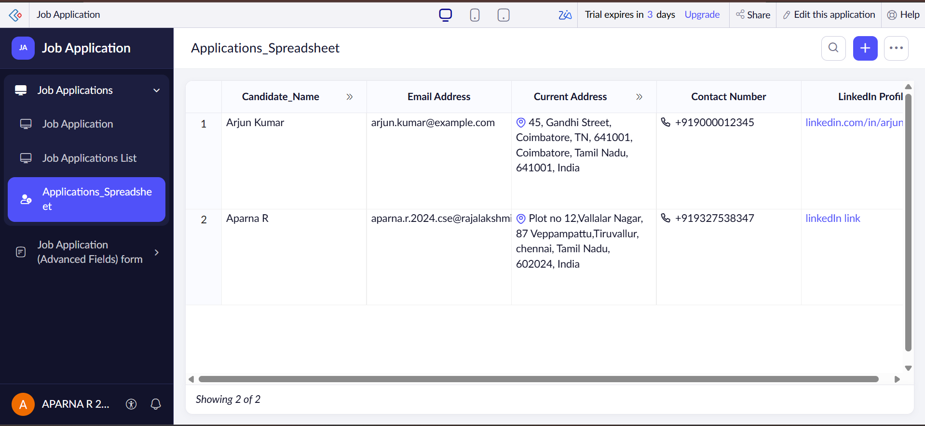
3. Kanban View
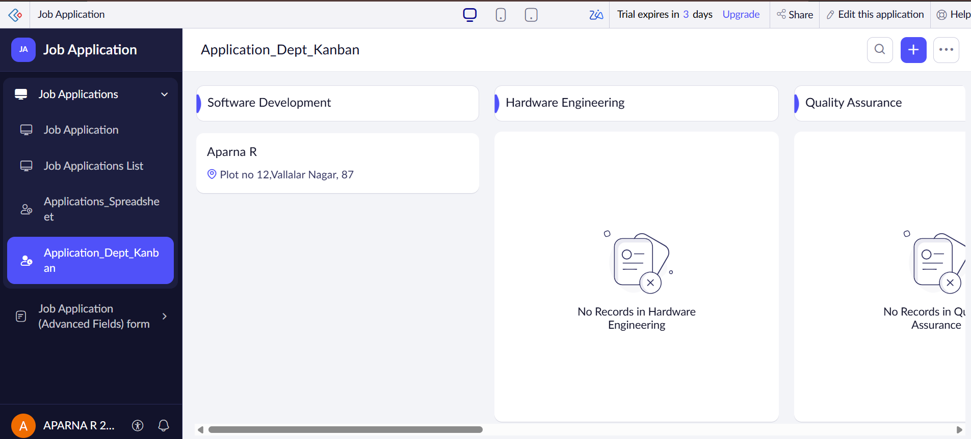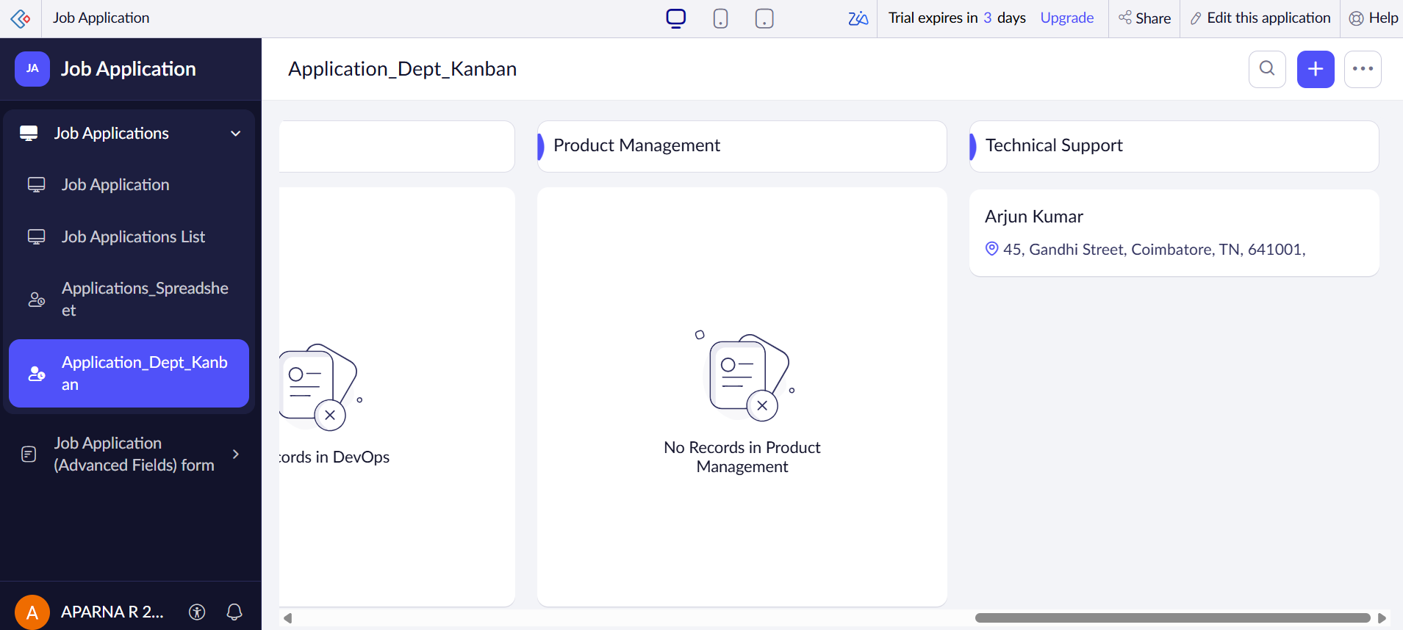

4. Calendar View
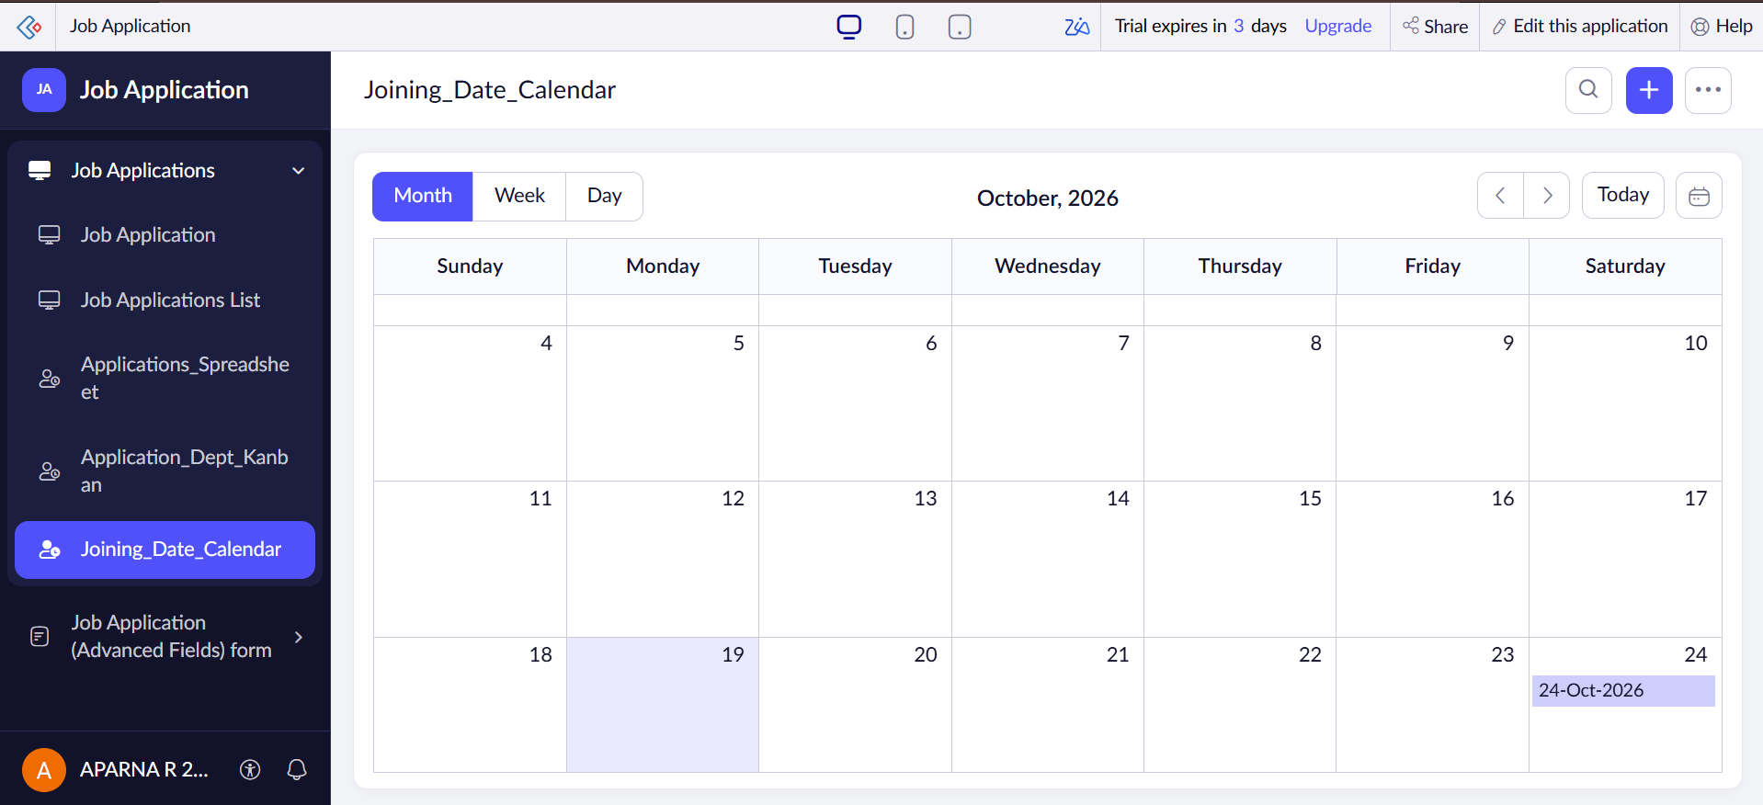
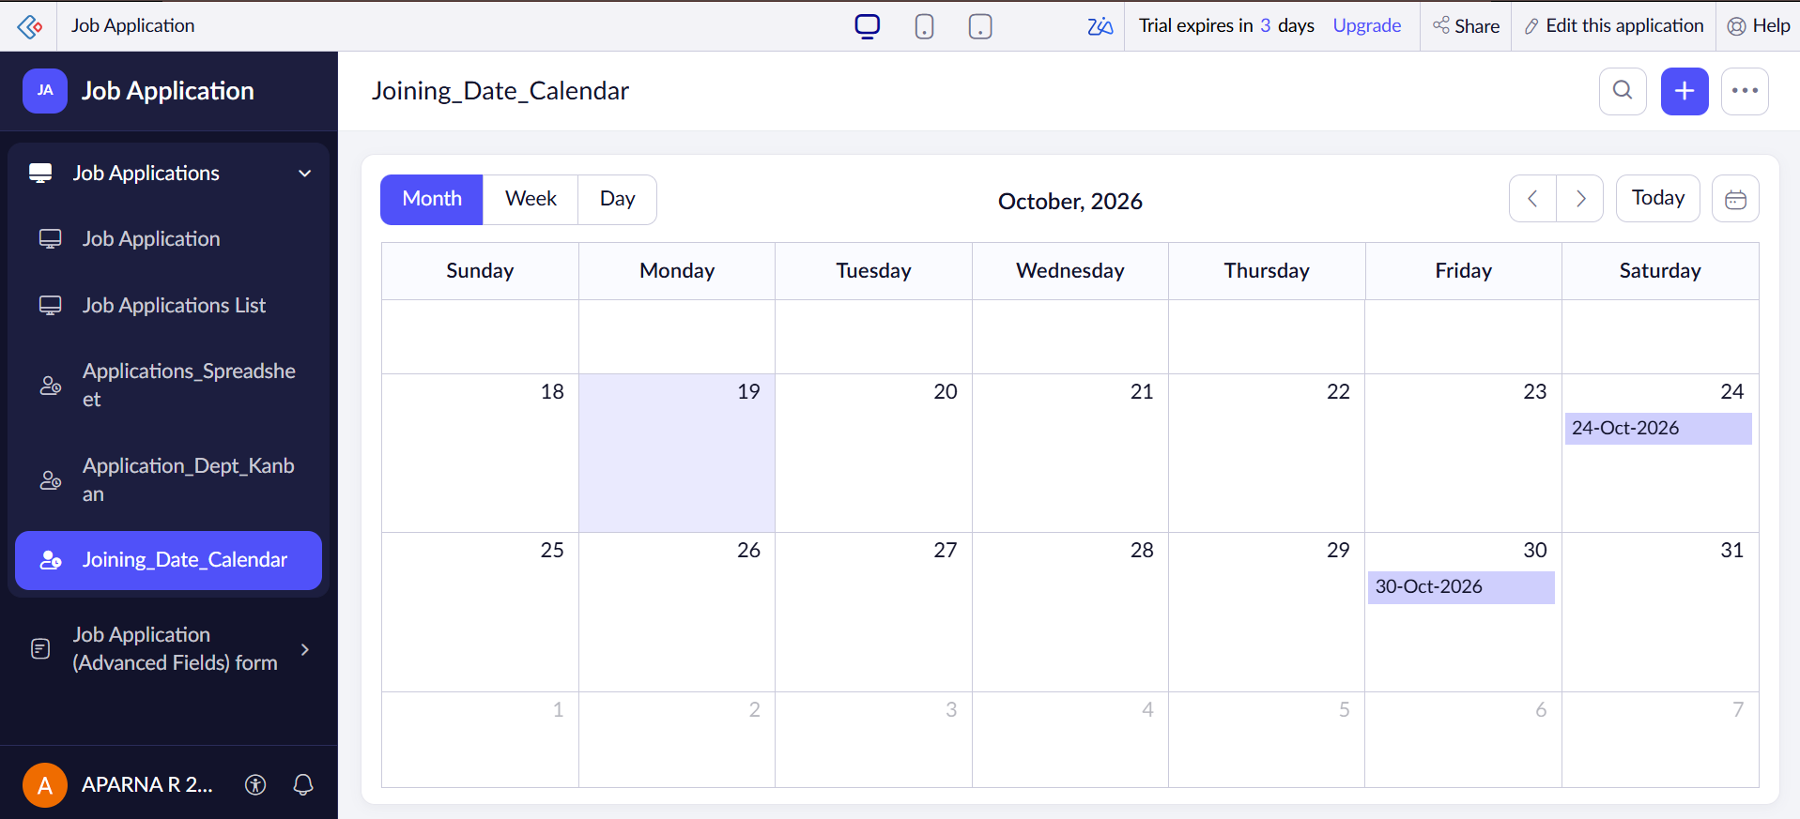
6. Map View
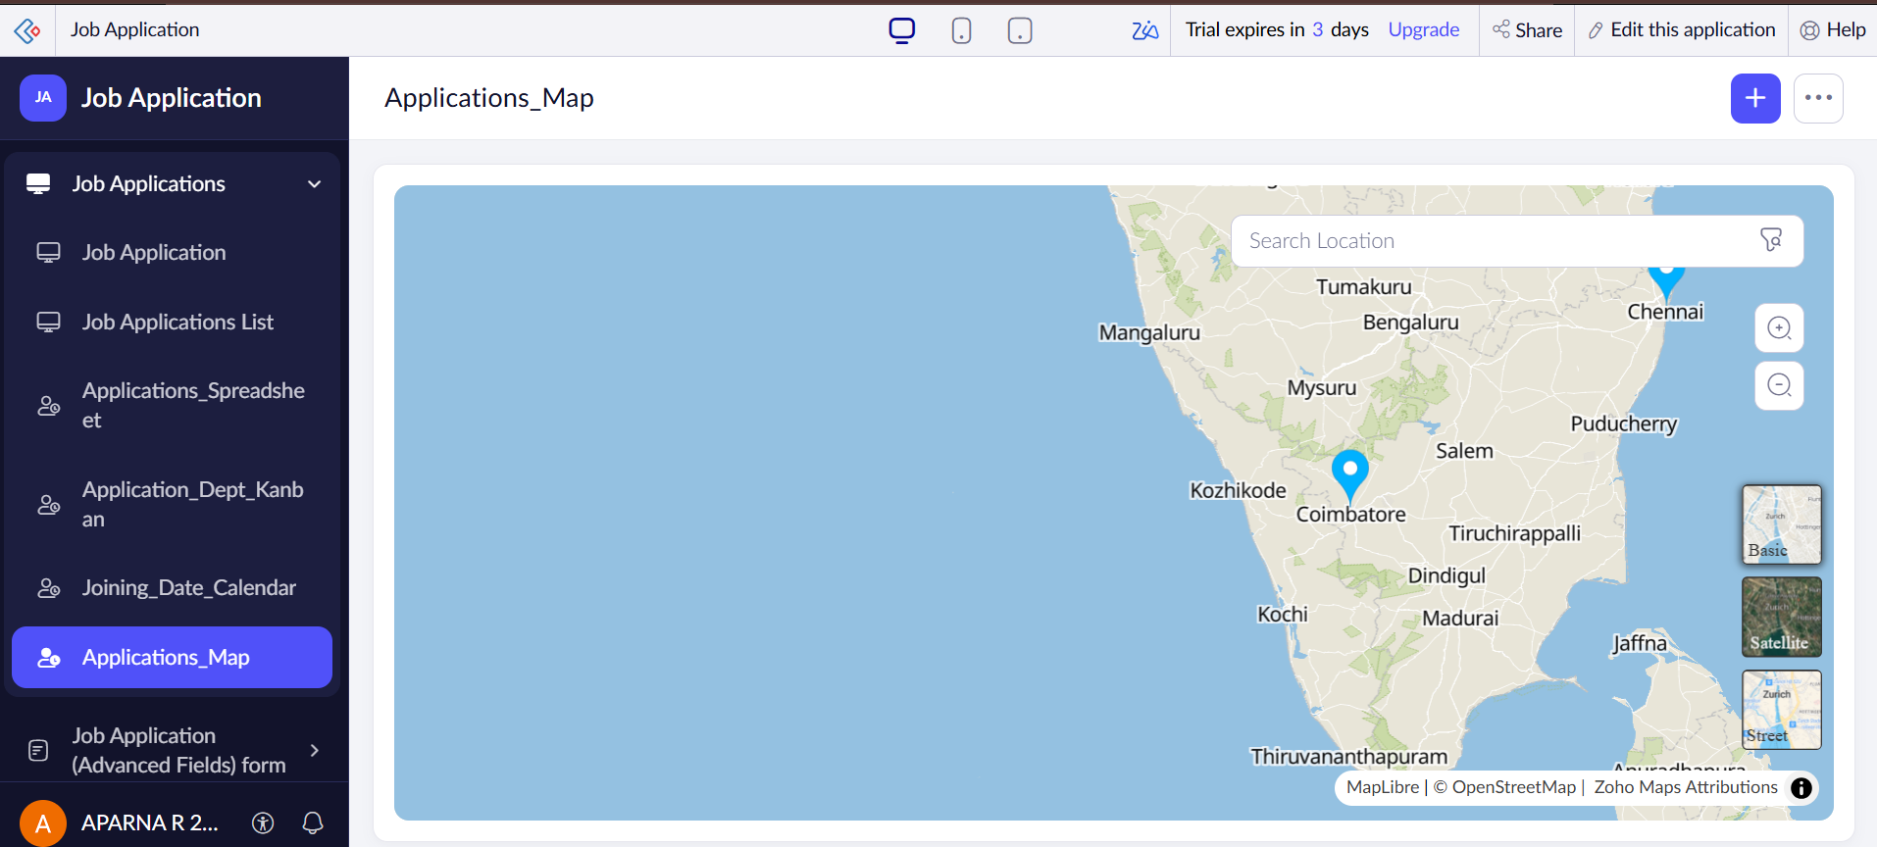

7. Timeline View
